|  |  |
| --- | --- |
| **logo** | **CHALAPATHI INSTITUTE OF ENGINEERING AND TECHNOLOGY**  **Chalapathi Nagar, Lam, Guntur-34** |

**DEPARTMENT OF ELECTRICAL AND ELECTRONICS ENGINEERING**

**Subject: – LINEAR CONTROL SYSTEMS**

|  |  |  |
| --- | --- | --- |
| Faculty Name: K.MURALI KRISHNA RAJU | Year / Sem: B.Tech in EEE 3/1 | Academic Year: 2019-20 |

**Scheme of Evaluation of ASSIGNMENT-1**

1. Define and explain open loop and closed loop system with an example?

* + Define open loop system -2M
  + Define closed loop system -2M
  + Example of open loop -4M
  + Example closed loop system -4M

2. write the differential equations governing the mechanical rotational system show in fig and determine the transfer function

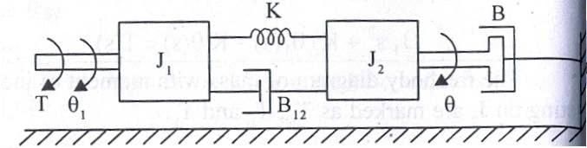

* + Differential equations of M1 Element -2M
  + Differential equations of M2 Element -2M
  + Transfer function from M1 and M2 equations -2M

3. Find the transfer function for the sys tem represented by the block diagram show in fig

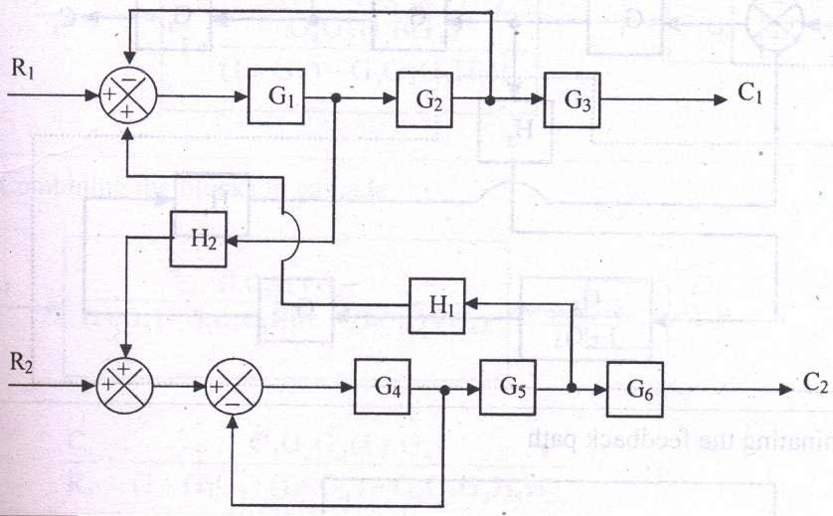

* + Application of block diagram reduction rules -6M
  + Find the transfer function  -6M

4. . Find the overall gain of the system whose signal flow graph is show in fig

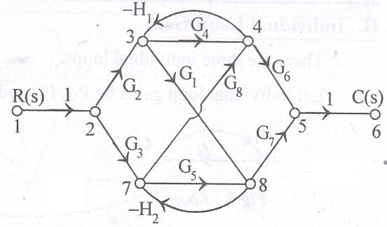

* Masons gain formula -2M
* Find the transfer function  -10M

5. Explain the DC servo motor and derive its transfer function

* + DC servo motor principle and operation -6M
  + DC servo motor transfer function -6M

6. Explain the synchro’s pair and derive its transfer function

* + Explain the synchro’s pair principle and operation -6M
  + synchro’s transfer function- 6M

**Signature of the faculty**

|  |  |
| --- | --- |
| **logo** | **CHALAPATHI INSTITUTE OF ENGINEERING AND TECHNOLOGY**  **Chalapathi Nagar, Lam, Guntur-34** |

**DEPARTMENT OF ELECTRICAL AND ELECTRONICS ENGINEERING**

**Subject: – LINEAR CONTROL SYSTEMS**

|  |  |  |
| --- | --- | --- |
| Faculty Name: K.MURALI KRISHNA RAJU | Year / Sem: B.Tech in EEE 3/1 | Academic Year: 2019-20 |

**Scheme of Evaluation of ASSIGNMENT-1 with CO & BT Mapping**

|  |  |  |  |  |
| --- | --- | --- | --- | --- |
| **Question Number** | **Question** | **Course Outcome** | **Taxonomy Level** | **Scheme of evaluation** |
| 1 | Define and explain open loop and closed loop system with an example? | C 311.1 | comprehension | 12 |
| 2 | write the differential equations governing the mechanical rotational system show in fig and determine the transfer function  scan0010 | C 311.1 | analysis | 12 |
| 3 | Find the transfer function for the sys tem represented by the block diagram show in fig  scan0009 | C 311.1 | knowledge | 12 |
| 4 | Find the overall gain of the system whose signal flow graph is show in fig  scan0011 | C 311.1 | knowledge | 12 |
| 5 | Explain the DC servo motor and derive its transfer function | C 311.1 | comprehension | 12 |
| 6 | Explain the synchro’s pair and derive its transfer function | C 311.1 | comprehension | 12 |

**Signature of the faculty**

|  |  |
| --- | --- |
| **logo** | **CHALAPATHI INSTITUTE OF ENGINEERING AND TECHNOLOGY**  **Chalapathi Nagar, Lam, Guntur-34** |

**DEPARTMENT OF ELECTRICAL AND ELECTRONICS ENGINEERING**

**Subject: – LINEAR CONTROL SYSTEMS**

|  |  |  |
| --- | --- | --- |
| Faculty Name: K.MURALI KRISHNA RAJU | Year / Sem: B.Tech in EEE 3/1 | Academic Year: 2019-20 |

**Scheme of Evaluation of MID-1**

**SECTION-A**

**Answer All Questions: (6 x 1 = 6 M)**

1. a) Define Control systems

b) Define electrical Zero position

c) Write Masons Gain Formula.

d) Define Stability.

e) Define Branch, and Node.

f) ) Define Steady State stability.

**SECTION-B**

1. Explain the effect of feedback on overall gain and stability.

* Effect of feedback on overall gain and stability. -6M

**(OR)**

3. Find the transfer function of the control system shown in fig

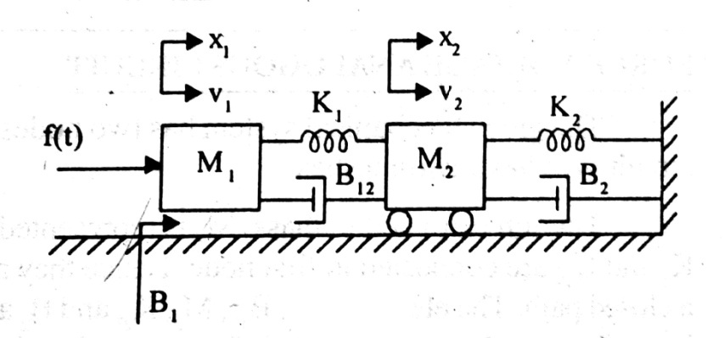

* transfer function of the control system -6M

**SECTION-C**

4. Define time response and explain time domain specifications

* Define time response -3M
* explain time domain specifications -3M

**(OR)**

5. Find the stability of the system 

* stability of the system  -6M

**Signature of the Faculty**

|  |  |
| --- | --- |
| **logo** | **CHALAPATHI INSTITUTE OF ENGINEERING AND TECHNOLOGY**  **Chalapathi Nagar, Lam, Guntur-34** |

**DEPARTMENT OF ELECTRICAL AND ELECTRONICS ENGINEERING**

**Subject: – LINEAR CONTROL SYSTEMS**

|  |  |  |
| --- | --- | --- |
| Faculty Name: K.MURALI KRISHNA RAJU | Year / Sem: B.Tech in EEE 3/1 | Academic Year: 2019-20 |

**Scheme of Evaluation of MID-1 with CO & BT Mapping**

|  |  |  |  |  |
| --- | --- | --- | --- | --- |
| **Question Number** | **Question** | **Course Outcome** | **Taxonomy Level** | **Scheme of evaluation** |
| 1 | a) Define Control systems | C311.1  C311.2  C311.3 | Knowledge | 1 |
| b) Define electrical Zero position | 1 |
| c) Write Masons Gain Formula. | 1 |
| d) Define Stability. | 1 |
| e) Define Branch, and Node. | 1 |
| f) ) Define Steady State stability. | 1 |
| 2. | Explain the effect of feedback on overall gain and stability | C311.1  C311.2 | Analysis | 6 |
| 3. | Find the transfer function of the control system shown in figNew Doc 2018-09-17 11 | C311.1  C311.2 | application | 6 |
| 4. | Define time response and explain time domain specifications | C311.1  C311.3 | Comprehension | 6 |
| 5. | Find the stability of the system | C311.1  C311.3 | application | 6 |

**Signature of the Faculty**